Project Title
Contract & Compliance Version-Intelligence Platform
Project Report submitted for the partial fulfilment of grade for the course

Data Structures and Algorithms -3 (25CS2103E)
in

A.Y. 2026-2027

Submitted by
S. Akshitha Reddy – 2520090178
K. Badari Narayana – 2520090165

Team Number: 38
Section: 12

Under the guidance of

Ms. K. Chandusha

Asst. Prof, CS&IT
Hyderabad-500090, Telangana, India.

K L (Deemed to be) University
DEPARTMENT OF COMPUTER SCIENCE ENGINEERING / COMPUTER SCIENCE AND INFORMATION TECHNOLOGY/ARTIFICIAL INTELLIGENCE & DATA SCIENCE



DECLARATION

The Mini Project Report entitled “Contract & Compliance Version-Intelligence Platform” is a record of Bonafide work of S. Akshitha Reddy – 2520090178, K. Badari Narayana – 2520090165. submitted in partial fulfillment for the award of B. Tech in Computer Science and Engineering/Computer Science and Information Technology/ Artifical Intelligence & data Science to the K L University. The results embodied in this report have not been copied from any other departments/University/Institute.

S. Akshitha Reddy – 2520090178
K. Badari Narayana – 2520090165

K L (Deemed to be) University
DEPARTMENT OF COMPUTER SCIENCE ENGINEERING / COMPUTER SCIENCE AND INFORMATION TECHNOLOGY
CERTIFICATE

This is to certify that the mini project based report entitled “Contract & Compliance Version-Intelligence Platform” is a bonafide work done and submitted by S. Akshitha Reddy – 2520090178, K. Badari Narayana – 2520090165. in partial fulfillment of the requirements for the award of the degree of BACHELOR OF TECHNOLOGY in Department of Computer Science Engineering/ Computer Science and Information Technology/Artificial Intelligence & Data Science, K L (Deemed to be University), during the academic year 2026-2027.

Signature of the Supervisor

Signature of the HOD Signature of the External Examiner

ACKNOWLEDGEMENT

The success in this project would not have been possible but for the timely help and guidance rendered by many people. Our wish to express my sincere thanks to all those who has assisted us in one way or the other for the completion of my project.

Our greatest appreciation to my guide, <<Guide Name>>, <<Designation>>, CSIT, which cannot be expressed in words for his/her tremendous support, encouragement and guidance for this project.

We express our gratitude to Dr. Khaja Shareef (CSIT), Head of the Department for Computer Science and Information Technology for providing us with adequate facilities, ways and means by which we are able to complete this project-based Lab.

We thank all the members of teaching and non-teaching staff members, and also who have assisted me directly or indirectly for successful completion of this project. Finally, I sincerely thank my parents, friends and classmates for their kind help and cooperation during my work.

S. Akshitha Reddy – 2520090178
K. Badari Narayana – 2520090165
TABLE OF CONTENTS

S.No. | Contents | Page no.
1. | Abstract | 6
2. | Introduction | 7
3. | Literature survey | 8
4. | Problem Statement and Objectives | 10
5. | Hardware and Software requirements | 11
6. | Implementation | 12
7. | Results & Discussion | 18
8. | Conclusion & Future Scope | 20
9. | References | 21

1. ABSTRACT

The Contract & Compliance Version-Intelligence Platform is a Java-based application developed to compare successive versions of a contract and to check each version against a set of compliance rules. The system treats a contract as an ordered collection of clauses and applies algorithmic techniques to find what has changed, how much it has changed, and whether the change introduces legal or regulatory risk.
The platform accepts an earlier and a later version of a contract as plain text, splits both into clauses, and normalises the wording. Rabin–Karp hashing is used to fingerprint clauses so that unchanged clauses are recognised quickly. Edit Distance, a dynamic programming technique, matches modified clauses and lists the exact word-level changes. The Aho–Corasick multi-pattern matching algorithm then scans the new version for risky phrases and verifies that mandatory clauses are still present. The results are presented as a version-change and compliance report.
The main objective of this project is to apply concepts from Design and Analysis of Algorithms (DSA-3) to a practical contract-management problem. The platform is intended for educational use. Its output is a decision-support aid for a human reviewer and not legal advice.
Team Name: <<Team Number>> (Section <<Section>>)
Team Logo (if any):
Team Members:
- S. Akshitha Reddy - 2520090178
- K. Badari Narayana - 2520090165

- INTRODUCTION

A contract rarely stays in its first form. During negotiation and renewal, clauses are added, removed, and reworded across many versions, and a small change in a figure or a phrase can alter the rights and obligations of the parties. Reviewing every version manually is slow, and important changes can easily be missed, especially when the documents are long.
Organisations must also ensure that each version follows internal policies and regulatory requirements. A clause that allows unlimited liability, termination without notice, or automatic renewal may create risk, and the absence of a mandatory clause such as data protection can lead to a compliance gap. Checking for such issues by reading alone is error-prone.
The Contract & Compliance Version-Intelligence Platform addresses these problems by combining version comparison with compliance scanning. It is implemented in Java and uses string-matching and dynamic programming algorithms: Rabin–Karp hashing for clause fingerprints, Edit Distance for matching and comparing clauses, and the Aho–Corasick automaton for scanning many risk phrases in a single pass.
The project also provides an opportunity to understand algorithm complexity and to see how several algorithms can be combined into one working tool. It can be useful for students, legal-operations teams, and developers who want to explore automated contract review. The rest of this report describes related work, the problem and objectives, the requirements, the implementation, the results, and the conclusion.
- LITERATURE SURVEY

1. DocuSign Contract Lifecycle Management
DocuSign Contract Lifecycle Management is a commercial platform that manages agreements from drafting to approval, signature, and storage. It provides templates, approval workflows, electronic signature, and a central repository so that teams can find and track their contracts. Its main strength is workflow and signing. It is not designed to study algorithmically how the wording of a clause changed between two versions.

2. Icertis Contract Intelligence
Icertis offers an AI-enabled contract intelligence platform for large organisations. It is designed to extract key terms and obligations from agreements, monitor compliance with them, and give a central view of contract data. Platforms of this kind rely on large-scale machine learning and enterprise integration, which makes them powerful but complex and costly for small teams and for learning purposes.

3. Ironclad
Ironclad is a digital contracting platform that supports contract creation, collaborative editing, redlining, approvals, and storage in one workflow. Its comparison of versions helps negotiators see what the other party has edited. It is a closed commercial product, so the comparison and matching techniques inside it cannot be studied, which this project addresses by implementing the algorithms openly.

4. Litera Kira
Kira is a machine-learning-based contract review tool, now part of Litera, that is widely used for due diligence. It identifies and extracts clauses and provisions from large sets of documents so that lawyers can review them faster. Its strength is clause identification using trained models, whereas the proposed platform uses deterministic algorithms with predictable behaviour and clear complexity bounds.

5. Luminance
Luminance is an AI-based legal document review platform that helps users read, compare, and analyse large numbers of contracts. It can highlight unusual or non-standard wording by comparing a document with others. Systems of this type depend on trained language models, whereas this project shows how classical string matching and dynamic programming can support a simpler rule-based review.

6. Text Comparison Tools (Word Compare and Git diff)
General-purpose tools such as the document compare feature of word processors and the diff utility of version-control systems such as Git compare two versions of a text and show insertions and deletions. The default diff in Git is based on the Myers difference algorithm. These tools show what changed, but they do not understand clauses and do not check the new text for risky phrases or for missing mandatory clauses.

7. Contract & Compliance Version-Intelligence Approach
The proposed platform combines the strengths of these approaches in a small, open implementation. It compares contracts at the clause level instead of the line level, fingerprints clauses for fast detection of unchanged text, and reports word-level changes using Edit Distance. It also scans the new version with an Aho–Corasick automaton and checks for missing mandatory clauses, giving version comparison and compliance checking in a single report.

- Problem Statement and Objectives

Problem Statement: Contracts change across several versions, and finding every modified clause and checking each version for risky or missing compliance terms by hand is slow and error-prone, so a system is needed to compare versions and screen them automatically.
Problem Description: Ordinary text-comparison tools show what changed but do not understand clauses or compliance, so risky wording added in a new version, or a mandatory clause removed from it, can go unnoticed.
Objectives:
- To develop a Java-based platform that compares two versions of a contract clause by clause.
- To split contracts into clauses and normalise the text before comparison.
- To fingerprint clauses using Rabin–Karp hashing so that unchanged clauses are recognised quickly.
- To apply the Edit Distance dynamic programming algorithm to match modified clauses and list word-level changes.
- To implement the Aho–Corasick algorithm for scanning many risky phrases in a single pass.
- To detect mandatory clauses that are missing from a contract version.
- To produce a report of added, removed, modified, and unchanged clauses together with risk alerts.
- To study the time complexity and the practical behaviour of the algorithms used.
The platform is intended to support contract review for educational purposes. Its output is decision support for a human reviewer and should not be treated as legal advice.
- HARDWARE AND SOFTWARE REQUIREMENTS

Hardware requirements
Processor | Intel Core i3 or equivalent and above
RAM | 4 GB minimum; 8 GB recommended
Storage | At least 1 GB of free space for the JDK and project files
Display | Standard monitor or laptop display
Internet | Required only to download the JDK and the code editor

Software requirements
Operating system | Windows 10/11, Linux, or macOS
Programming language | Java (JDK 17 or later)
Core algorithms | Rabin–Karp, Aho–Corasick, Edit Distance (dynamic programming)
Build and run | javac and java command line, or an IDE
Input format | Plain-text contract files, one clause per line
Code editor | Visual Studio Code or IntelliJ IDEA
- IMPLEMENTATION

The core engine is implemented in Java using four main modules, supported by a ComplianceScanner class, a VersionDiff class, and a Main class. The modules split and normalise contract text, fingerprint clauses, scan for risky phrases, and compare clause wording. The code shown below was compiled and executed to produce the results in this report. The four modules demonstrate the string matching, multi-pattern matching, and dynamic programming concepts from DSA-3.

Module 1: Clause Parsing and Preprocessing (ClauseParser.java)
Clause parsing converts a contract into a list of clauses and standardises each clause before comparison. Each non-empty line is treated as one clause. The text is converted to lowercase, the clause number and punctuation are removed, and extra spaces are normalised.
package com.cvip;

import java.util.ArrayList;
import java.util.List;

public class ClauseParser {

public List<String> splitClauses(String contract) {
List<String> clauses = new ArrayList<>();
if (contract == null) {
return clauses;
}
for (String line : contract.split("\\R")) {
String clause = line.trim();
if (!clause.isEmpty()) {
clauses.add(clause);
}
}
return clauses;
}

public String normalize(String clause) {
if (clause == null) {
return "";
}
return clause.toLowerCase()
.replaceAll("^\\d+\\.\\s*", "")
.replace("'", "")
.replaceAll("[^a-z0-9\\s]", " ")
.replaceAll("\\s+", " ")
.trim();
}

public String[] tokenize(String clause) {
String cleaned = normalize(clause);
if (cleaned.isEmpty()) {
return new String[0];
}
return cleaned.split(" ");
}
}
Working: The splitClauses() method creates the clause list. The normalize() method cleans a clause, and tokenize() divides it into words, which are used by the fingerprint and edit distance modules. Each method runs in O(n) time for a clause of n characters.

Module 2: Rabin–Karp Clause Fingerprinting (ClauseFingerprint.java)
The Rabin–Karp algorithm uses a polynomial rolling hash. Here it is used in two ways: hash() produces a fingerprint of a whole normalised clause so that unchanged clauses can be recognised quickly, and countMatches() searches a text for a phrase using a rolling hash.
package com.cvip;

public class ClauseFingerprint {

private static final long BASE = 256;
private static final long MOD = 1_000_000_007L;

public long hash(String text) {
long h = 0;
for (int i = 0; i < text.length(); i++) {
h = (h * BASE + text.charAt(i)) % MOD;
}
return h;
}

public int countMatches(String text, String pattern) {
int n = text.length();
int m = pattern.length();
if (m == 0 || m > n) {
return 0;
}
long highestPower = 1;
for (int i = 1; i < m; i++) {
highestPower = (highestPower * BASE) % MOD;
}
long patternHash = hash(pattern);
long windowHash = hash(text.substring(0, m));
int count = 0;
for (int i = 0; i <= n - m; i++) {
if (patternHash == windowHash
&& text.regionMatches(i, pattern, 0, m)) {
count++;
}
if (i < n - m) {
windowHash = (windowHash
- text.charAt(i) * highestPower % MOD + MOD) % MOD;
windowHash = (windowHash * BASE + text.charAt(i + m)) % MOD;
}
}
return count;
}
}
Working: hash() computes the polynomial hash with base 256 modulo 1,000,000,007. In countMatches(), the hash of the sliding window is updated in constant time, and when the hashes match the actual characters are compared to avoid counting hash collisions. The expected running time is O(n + m), although the worst case is O(nm).

Module 3: Aho–Corasick Multi-Pattern Matching (AhoCorasick.java)
The Aho–Corasick algorithm builds a trie of all search phrases and adds failure links so that every phrase can be found in one pass over the text. The compliance scanner adds risky phrases such as “unlimited liability” and “without notice” to this automaton and scans each clause.
package com.cvip;

import java.util.ArrayDeque;
import java.util.ArrayList;
import java.util.HashMap;
import java.util.List;
import java.util.Map;
import java.util.Queue;

public class AhoCorasick {

private static class Node {
Map<Character, Node> next = new HashMap<>();
Node fail;
List<String> output = new ArrayList<>();
}

private final Node root = new Node();

public void addPattern(String pattern) {
Node cur = root;
for (char c : pattern.toCharArray()) {
cur = cur.next.computeIfAbsent(c, k -> new Node());
}
cur.output.add(pattern);
}

public void build() {
Queue<Node> queue = new ArrayDeque<>();
for (Node child : root.next.values()) {
child.fail = root;
queue.add(child);
}
while (!queue.isEmpty()) {
Node node = queue.poll();
for (Map.Entry<Character, Node> e : node.next.entrySet()) {
char c = e.getKey();
Node child = e.getValue();
Node f = node.fail;
while (f != root && !f.next.containsKey(c)) {
f = f.fail;
}
child.fail = f.next.containsKey(c) ? f.next.get(c) : root;
child.output.addAll(child.fail.output);
queue.add(child);
}
}
}

public List<String> search(String text) {
List<String> found = new ArrayList<>();
Node cur = root;
for (char c : text.toCharArray()) {
while (cur != root && !cur.next.containsKey(c)) {
cur = cur.fail;
}
if (cur.next.containsKey(c)) {
cur = cur.next.get(c);
}
found.addAll(cur.output);
}
return found;
}
}
Working: addPattern() inserts a phrase into the trie. build() computes the failure links with a breadth-first traversal and merges the output lists. search() reads the text once and reports every phrase that ends at each position. Building takes time proportional to the total pattern length, and searching takes O(n + z), where n is the text length and z is the number of matches.

Module 4: Edit Distance (EditDistance.java)
The Edit Distance algorithm uses dynamic programming to find the minimum number of insertions, deletions, and substitutions needed to turn one sequence into another. Here it works on words instead of characters, so it can measure how much a clause changed between two versions and list the changed words.
package com.cvip;

import java.util.ArrayList;
import java.util.Collections;
import java.util.List;

public class EditDistance {

private int[][] table(String[] a, String[] b) {
int m = a.length;
int n = b.length;
int[][] dp = new int[m + 1][n + 1];
for (int i = 0; i <= m; i++) {
dp[i][0] = i;
}
for (int j = 0; j <= n; j++) {
dp[0][j] = j;
}
for (int i = 1; i <= m; i++) {
for (int j = 1; j <= n; j++) {
int cost = a[i - 1].equals(b[j - 1]) ? 0 : 1;
dp[i][j] = Math.min(
Math.min(dp[i - 1][j] + 1, dp[i][j - 1] + 1),
dp[i - 1][j - 1] + cost
);
}
}
return dp;
}

public int distance(String[] a, String[] b) {
return table(a, b)[a.length][b.length];
}

public double similarity(String[] a, String[] b) {
int longest = Math.max(a.length, b.length);
if (longest == 0) {
return 1.0;
}
return 1.0 - (double) distance(a, b) / longest;
}

public List<String> changes(String[] a, String[] b) {
int[][] dp = table(a, b);
List<String> out = new ArrayList<>();
int i = a.length;
int j = b.length;
while (i > 0 || j > 0) {
if (i > 0 && j > 0 && a[i - 1].equals(b[j - 1])) {
i--;
j--;
} else if (i > 0 && j > 0
&& dp[i][j] == dp[i - 1][j - 1] + 1) {
out.add("'" + a[i - 1] + "' -> '" + b[j - 1] + "'");
i--;
j--;
} else if (i > 0 && dp[i][j] == dp[i - 1][j] + 1) {
out.add("-'" + a[i - 1] + "'");
i--;
} else {
out.add("+'" + b[j - 1] + "'");
j--;
}
}
Collections.reverse(out);
return out;
}
}
Working: table() fills a two-dimensional table in which dp[i][j] is the minimum cost for the first i words of one clause and the first j words of the other. distance() reads the last cell, and similarity() converts it into a score between 0 and 1. changes() traces back through the table to list the inserted, deleted, and substituted words. The time and space complexity is O(mn) for clauses of m and n words.

How these modules work together
The VersionDiff class coordinates the modules. It splits both versions into clauses, uses fingerprints to mark unchanged clauses, and uses Edit Distance to pair each remaining clause with its closest match (similarity of at least 0.40) and mark it as modified. Clauses with no match are reported as removed or added. The ComplianceScanner class then runs the Aho–Corasick automaton on modified and added clauses and uses Rabin–Karp search to detect missing mandatory clauses.
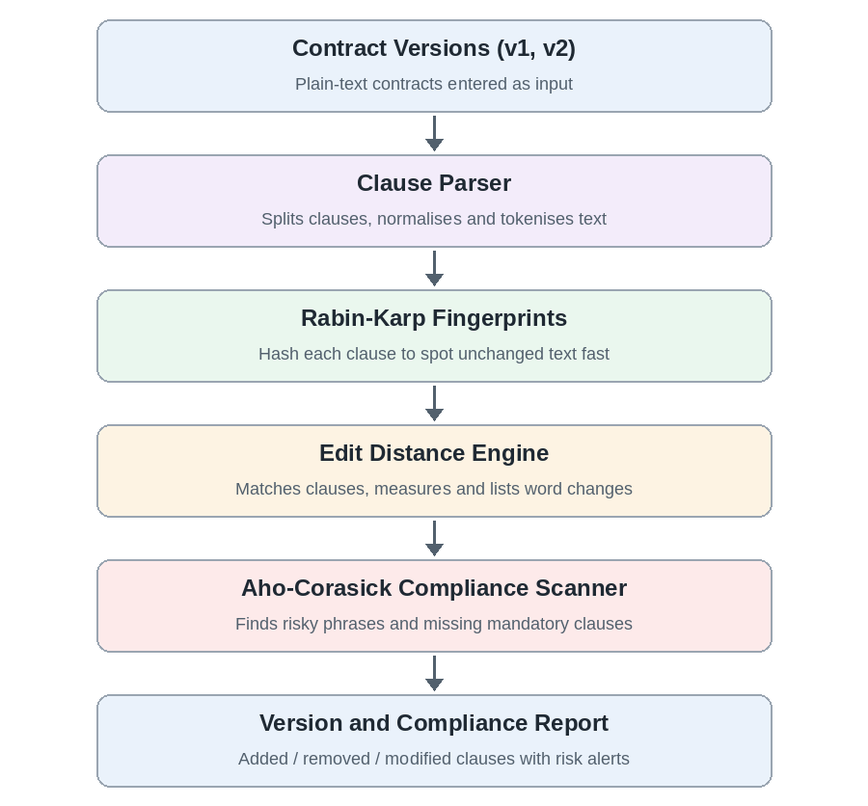
- RESULTS & DISCUSSION

The four modules were compiled and run on two sample versions of a service contract. Version 1 has six clauses. Version 2 changes the payment period, widens the termination right, makes liability unlimited, removes the data protection clause, and adds an automatic renewal clause. The outputs are shown below.
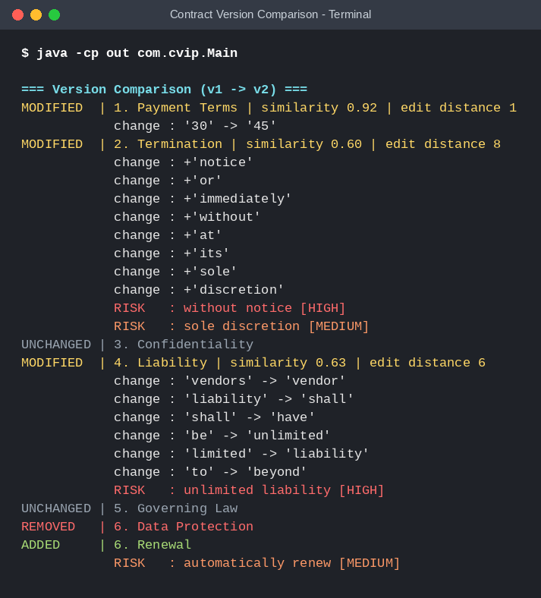
Figure 1: Version comparison of contract v1 and v2. Unchanged, modified, removed, and added clauses are listed with similarity scores, word-level changes, and risk alerts.
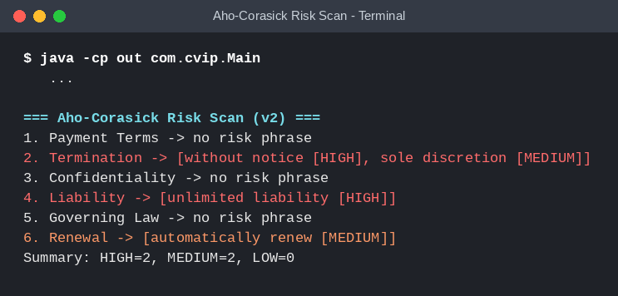
Figure 2: Aho–Corasick risk scan of version 2. Four risky phrases are found in clauses 2, 4, and 6, giving two HIGH and two MEDIUM alerts.
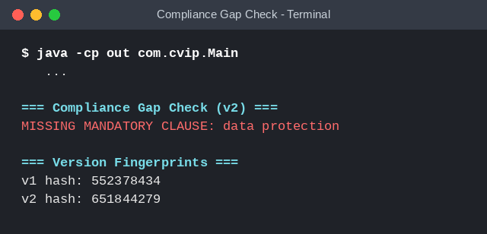
Figure 3: Compliance gap check and version fingerprints. The mandatory data protection clause is reported as missing, and the two version hashes differ.
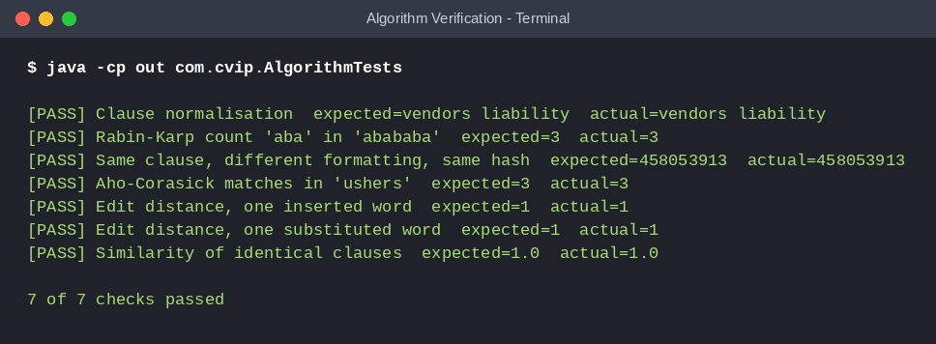
Figure 4: Algorithm verification. All seven checks on clause normalisation, Rabin–Karp, Aho–Corasick, and Edit Distance passed.
Discussion: Of the six clauses in version 1, two were unchanged, three were modified, and one was removed, and version 2 added one new clause. Three clauses carried risk alerts, and the removal of the data protection clause created a compliance gap. These results show that the platform separates harmless edits from risky ones and points the reviewer to the clauses that need attention.
- CONCLUSION & FUTURE SCOPE

Conclusion
The Contract & Compliance Version-Intelligence Platform demonstrates how Design and Analysis of Algorithms concepts can be applied to contract review. The objectives were met: the platform splits contracts into clauses, compares two versions at the clause level, lists word-level changes, flags risky phrases, and reports missing mandatory clauses.
The project combines Rabin–Karp hashing, the Aho–Corasick automaton, and Edit Distance. Each algorithm has a clear role, and together they show how fast fingerprinting, multi-pattern matching, and dynamic programming can support one application. The test run on two sample versions of a service contract and the seven verification checks confirmed the expected behaviour.
The project serves as an educational demonstration of algorithm design. Its alerts are rule-based indicators that help a reviewer focus on important changes, and they should not be treated as legal advice.

Future Scope
- Document Import: Read contracts directly from PDF and DOCX files instead of plain text.
- Semantic Matching: Use word embeddings or language models to detect paraphrased clauses and changes in meaning.
- Configurable Rules: Let users define their own risk phrases, severity levels, and mandatory clauses for each jurisdiction.
- Multi-Version History: Track a chain of versions and show the full history of every clause.
- Visual Redlining: Highlight additions and deletions directly in the clause text, as in a redline view.
- Web Interface: Build a web front end and a REST API so that teams can upload and review contracts in a browser.
- Performance Evaluation: Measure execution time and memory use for large contracts and many versions.
- Reports and Audit Trail: Export comparison results as reports and keep a record of who changed what and when.
- REFERENCES

- DocuSign. DocuSign Contract Lifecycle Management. https://www.docusign.com/
- Icertis. Icertis Contract Intelligence. https://www.icertis.com/
- Ironclad. Ironclad Digital Contracting Platform. https://ironcladapp.com/
- Litera. Litera Kira Contract Review. https://www.litera.com/
- Luminance. Luminance Legal AI Platform. https://www.luminance.com/
- Git Project. git-diff Documentation. https://git-scm.com/docs/git-diff
- Aho, A. V., and Corasick, M. J. (1975). “Efficient String Matching: An Aid to Bibliographic Search.” Communications of the ACM, 18(6), 333–340.
- Karp, R. M., and Rabin, M. O. (1987). “Efficient Randomized Pattern-Matching Algorithms.” IBM Journal of Research and Development, 31(2), 249–260.
- Wagner, R. A., and Fischer, M. J. (1974). “The String-to-String Correction Problem.” Journal of the ACM, 21(1), 168–173.
- Cormen, T. H., Leiserson, C. E., Rivest, R. L., and Stein, C. (2022). Introduction to Algorithms, 4th edition. MIT Press.

